

INDUSTRIAL PROPERTY PUBLICATION
(Expired Trademarks)

No. 09 7/7/2026

EDITORIAL
The Industrial Property Expired Trademark publication is provided for under the Liberia Intellectual Property Act of 2016, Section 10.9 and the Revised Administrative Trademark Regulation No. 001/tm/08/2018, Section 12.1
– 12.3

Published and edited by:
Liberia Intellectual Property Office
Email: Website: lipo.gov.lr

© Liberia Intellectual Property Office 2026

PUBLICATION OF EXPIRED TRADEMARKS IN THE OFFICIAL REGISTRY SYSTEM

The Liberia Intellectual Property Office (LIPO), acting under the authority of the Liberia Intellectual Property Act of 2016 and the Revised Administrative Trademark Regulation No. 001/tm/08/2018, hereby gives formal notice to the public, trademark proprietors, right holders, legal
Representatives, and all interested parties that the trademark(s) listed in this publication have been removed from the National Trademark Registry due to expiration and non-renewal in accordance with the law.

I. Provisions of the 2016 Liberia Intellectual Property Act

Section 10.9 – Term of Registration; Renewal:

- A trademark is registered for ten (10) years from the date of registration.
- Registration may be renewed for consecutive 10-year periods upon meeting requirements and paying the renewal fee.
- A six (6) month grace period is allowed for late renewal, subject to a surcharge.
- Failure to renew within the prescribed period and grace period will result in lapse of the registration.

II. Provisions of the Revised Administrative Trademark Regulation No. 001/tm/08/2018

Section 12.1 – 12.3: Outlines procedures and conditions for ten-year registration, renewals, notifications, and late renewals.

Section 13bis: A lapsed trademark (due to non-renewal) may be restored within six (6) months from removal by submitting Form M6 and paying the restoration fee.

Section 16.2: Any alteration, renewal, or removal must be recorded in the Register and published in the official LIPO Journal.

EXPLANATION OF REFERENCE NUMBERS AND SYMBOLS IN THIS PUBLICATION

(111) – Trademark Registration
(231) – Expiration Date
(540) – Trademark
(511) - Nice Classification
(731) – Owner Name
(740) – Representative/Agent Name and Address

Expired Trademark

(111) | LR/M/2010/00115
(231) | MAY 7, 2010
(540) | 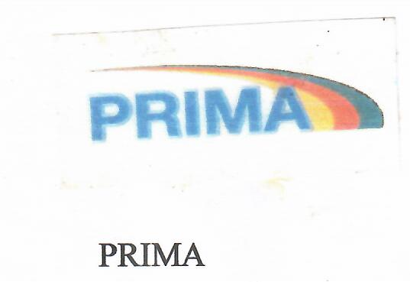
(511) | 12, 21, & 25
(731) | FOR AND ON BEHALF OF: HEXAGON GmbH & Co. KG.
(740) | T. NEGBALEE WARNER, COUNSELLOR-AT-LAW, PIERRE, TWEH & ASSOCIATES, PALM HOTEL, BUILDING BROAD & RANDALL STREETS, P.O. BOX 10-2536, 1000 MONROVIA, 10 LIBERIA

(111) | LR/M/2010/00159
(231) | AUGUST 12, 2010
(540) | 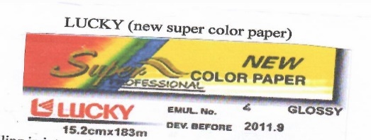
(511) | 01
(731) | FOR AND BEHALF OF: ABANOUB USA CO., INC,
(740) | ALFRED V. TUBMAN, ATTORNEY-AT-LAW, CORPORATION SERVICES (LIBERIA) INC. P.O. BOX 1597 MONROVIA, LIBERIA

(111) | LR/M/2010/00112
(231) | MAY, 17, 2010
(540) | 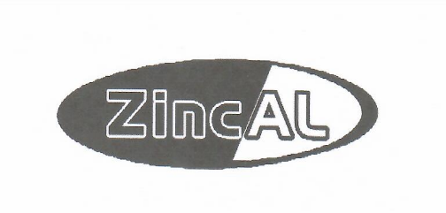
(511) | 06
(731) | FOR AND BEHALF OF : SAFAL INVESTMENT (MANURITIUS) LIMITED .00
(740) | ALFRED V. TUBMAN, ATTORNEY-AT-LAW, CORPORATION SERVICES (LIBERIA) INC. P.O. BOX 1597 MONROVIA, LIBERIA

(111) | LR/M/2010/00010
(231) | MARCH 15, 2010
(540) | 
(511) | 09
(731) | FOR AND BEHALF OF: FLYANG COMMUNICATIONS TECHNOLOGY LIMITED
(740) | ALFRED V. TUBMAN, ATTORNEY-AT-LAW, CORPORATION SERVICES (LIBERIA) INC. P.O. BOX 1597 MONROVIA, LIBERIA

(111) | LR/M/2010/00208
(231) | AUGUST 18, 2010
(540) | 
(511) | 29, 30, & 32
(731) | FOR AND BEHALF OF: SUPPLYING WEST AFRICA TRADERS, INC
(740) | J. JOHNNY MOMOH, COUNSELLOR-AT-LAW, SHERMAN INC., R. FOLE SHERMAN LAW BUILDING, 17TH STREET AND CHEESEMAN AVENUE, MONROVIA, LIBERIA

(111) | LR/M/2010/00196
(231) | OCTOBER 7, 2010
(540) | 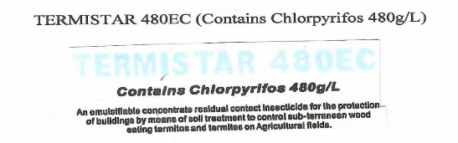
(511) | 01
(731) | FOR AND BEHALF OF: MIAGRO LIBERIA LTD.,
(740) | ALFRED V. TUBMAN, ATTORNEY-AT-LAW, CORPORATION SERVICES (LIBERIA) INC. P.O. BOX 1597 MONROVIA, LIBERIA

(111) | LR/M/2010/00207
(231) | AUGUST 18, 2010
(540) | 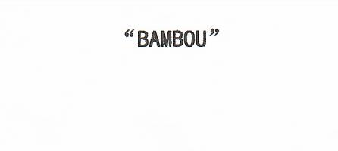
(511) | 29, 30, & 32
(731) | FOR AND BEHALF OF: SUPPLYING WEST AFRICA TRADERS, INC
(740) | J. JOHNNY MOMOH, COUNSELLOR-AT-LAW, SHERMAN INC., R. FOLE SHERMAN LAW BUILDING, 17TH STREET AND CHEESEMAN AVENUE, MONROVIA, LIBERIA

(111) | LR/M/2010/00124
(231) | APRIL 27, 2010
(540) | 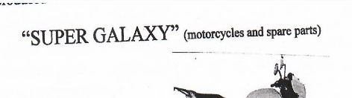
(511) | 12
(731) | FOR AND BEHALF OF: M.Y. STORE
(740) | ALFRED V. TUBMAN, ATTORNEY-AT-LAW, CORPORATION SERVICES (LIBERIA) INC. P.O. BOX 1597 MONROVIA, LIBERIA

(111) | LR/M/2010/00139
(231) | JUNE 7, 2010
(540) | 
(511) | 29, 30 & 31
(731) | FOR AND BEHALF OF: SUPPLYING WEST AFRICA TRADERS, (SWAT) INC
(740) | J. JOHNNY MOMOH, COUNSELLOR-AT-LAW, MOMOH & ASSOCIATES LAW FIRM, 8TH STREET, SINKOR, MONROVIA, LIBERIA

(111) | LR/M/2010/00248
(231) | OCTOBER 31, 2010
(540) | 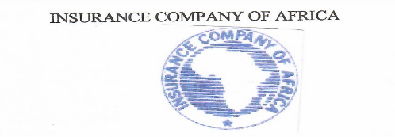
(511) | 36
(731) | FOR AND BEHALF OF: INSURANCE COMPANY OF AFRICA
(740) | ALFRED V. TUBMAN, ATTORNEY-AT-LAW, CORPORATION SERVICES (LIBERIA) INC. P.O. BOX 1597 MONROVIA, LIBERIA

(111) | LR/M/2010/00141
(231) | JUNE 7, 2010
(540) | 
(511) | 29. 30 & 32
(731) | FOR AND BEHALF OF: SUPPLYING WEST AFRICA TRADERS, INC
(740) | J. JOHNNY MOMOH, COUNSELLOR-AT-LAW, SHERMAN INC., R. FOLE SHERMAN LAW BUILDING, 17TH STREET AND CHEESEMAN AVENUE, MONROVIA, LIBERIA

(111) | LR/M/2010/00202
(231) | JULY 29, 2010
(540) | 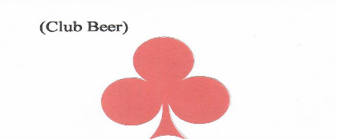
(511) | 32
(731) | FOR AND BEHALF OF: MONROVIA BREWERIES, INC
(740) | J. JOHNNY MOMOH, COUNSELLOR-AT-LAW, SHERMAN INC., R. FOLE SHERMAN LAW BUILDING, 17TH STREET AND CHEESEMAN AVENUE, MONROVIA, LIBERIA

(111) | LR/M/2010/00277
(231) | NOVEMBER 17, 2010
(540) | 
(511) | 25
(731) | FOR AND BEHALF OF: DAFENG ENTERPRISE
(740) | ALFRED V. TUBMAN, ATTORNEY-AT-LAW, CORPORATION SERVICES (LIBERIA) INC. P.O. BOX 1597 MONROVIA, LIBERIA

(111) | LR/M/2010/00144
(231) | JUNE 18, 2010
(540) | 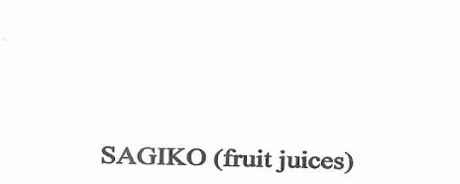
(511) | 32
(731) | FOR AND BEHALF OF: CHIA KHIM LEE FOOD INDUSTRIES PTE LTD
(740) | ALFRED V. TUBMAN, ATTORNEY-AT-LAW, CORPORATION SERVICES (LIBERIA) INC. P.O. BOX 1597 MONROVIA, LIBERIA

(111) | LR/M/2010/00107
 | APRIL 21, 2010
(540) | 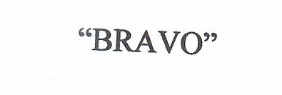
(511) | 05 & 32
(731) | FOR AND BEHALF OF: BEVERAGE AND BOTTLING COMPANY
(740) | J. JOHNNY MOMOH, COUNSELLOR-AT-LAW, SHERMAN INC., R. FOLE SHERMAN LAW BUILDING, 17TH STREET AND CHEESEMAN AVENUE, MONROVIA, LIBERIA

(111) | LR/M/2010/00116
 | MAY 17, 2010
(540) | 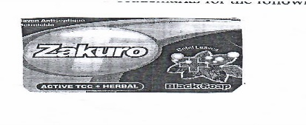
(511) | 05
(731) | FOR AND BEHALF OF: FRANCO-ASIA ENTERPRISE SINGAPORE PTELTED
(740) | ALFRED V. TUBMAN, ATTORNEY-AT-LAW, CORPORATION SERVICES (LIBERIA) INC. P.O. BOX 1597 MONROVIA, LIBERIA

(111) | LR/M/2010/00002
 | JANUARY 25, 2010
(540) | 
(511) | 32
(731) | FOR AND BEHALF OF: COWBELL INTERNATIONAL INC
(740) | ALFRED V. TUBMAN, ATTORNEY-AT-LAW, CORPORATION SERVICES (LIBERIA) INC. P.O. BOX 1597 MONROVIA, LIBERIA

(111) | LR/M/2010/00286
 | JANUARY 3, 2010
(540) | 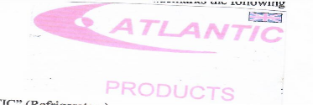
(511) | 11
(731) | FOR AND BEHALF OF: HARRY’S LIBERIA, INC
(740) | JERRY D.K. GALAWOLO, ATTORNEY-AT-LAW GONGOLE & ASSOCIATES, INC, CAMP JOHNSON, OPPOSITE S.D.A. CHURCH, MONROVIA, LIBERIA

(111) | LR/M/2010/00181
 | MAY 17, 2010
(540) | 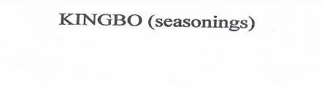
(511) | 30
(731) | FOR AND BEHALF OF: HERICO LIMITED
(740) | ERIC B. MORLU, ATTORNEY-AT-LAW, JONES & JONES ATTORNEY, & COUNSELLOR-AT-LAW, P.O. BOX 10-1891, RANDALL STREET, (ABOVE CHARIF PHARMACY) MONROVIA, LIBERIA

(111) | LR/M/2010/00182
 | MAY 21, 2010
(540) | 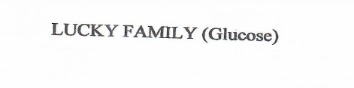
(511) | 05
(731) | FOR AND BEHALF OF: SAI EXPORTS
(740) | OMEJIA & ASSOCIATES, RANDALL STREET, BACK OF ABEER OF PHARMACY BUILDING, P.O. BOX 1223, MONROVIA, LIBERIA

(111) | LR/M/2010/00057
 | FEBRUARY 18, 2010
(540) | 
(511) | 03
(731) | FOR AND BEHALF OF: SOULMATE INDUSTRIES LIMITED
(740) | ALFRED V. TUBMAN, ATTORNEY-AT-LAW, CORPORATION SERVICES (LIBERIA) INC. P.O. BOX 1597 MONROVIA, LIBERIA

(111) | LR/M/2010/00203
 | AUGUST 12, 2010
(540) | 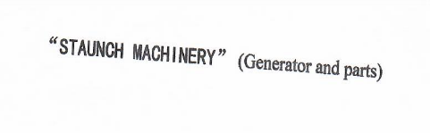
(511) | 07
(731) | FOR AND BEHALF OF: FEDRAL CORPORATION
(740) | ALFRED V. TUBMAN, ATTORNEY-AT-LAW, CORPORATION SERVICES (LIBERIA) INC. P.O. BOX 1597 MONROVIA, LIBERIA

(111) | LR/M/2010/00141
 | JUNE 7, 2010
(540) | 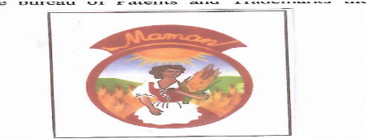
(511) | 29, 30, & 32
(731) | FOR AND BEHALF OF: SUPPLYING WEST AFRICA TRADES, INC
(740) | J. JOHNNY MOMOH, COUNSELLOR-AT-LAW, SHERMAN INC., R. FOLE SHERMAN LAW BUILDING, 17TH STREET AND CHEESEMAN AVENUE, MONROVIA, LIBERIA

(111) | LR/M/2010/00141
 | JUNE 7, 2010
(540) | 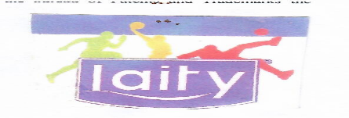
(511) | 29, 30, & 32
(731) | FOR AND BEHALF OF: SUPPLYING WEST AFRICA TRADES, INC
(740) | J. JOHNNY MOMOH, COUNSELLOR-AT-LAW, SHERMAN INC., R. FOLE SHERMAN LAW BUILDING, 17TH STREET AND CHEESEMAN AVENUE, MONROVIA, LIBERIA

(111) | LR/M/2010/00284
 | DECEMBER 29, 2010
(540) | 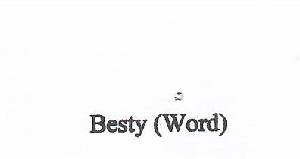
(511) | 29 & 30
(731) | FOR AND BEHALF OF: AFFILIATED TRADING COMPANY AND BARBAR MOTORS CORPORATION
(740) | ALFRED V. TUBMAN, ATTORNEY-AT-LAW, CORPORATION SERVICES (LIBERIA) INC. P.O. BOX 1597 MONROVIA, LIBERIA

(111) | LR/M/2010/00282
 | DECEMBER 29, 2010
(540) | 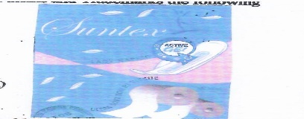
(511) | 16
(731) | FOR AND BEHALF OF: AFFILIATED TRADING COMPANY AND BARBAR MOTORS CORPORATION
(740) | ALFRED V. TUBMAN, ATTORNEY-AT-LAW, CORPORATION SERVICES (LIBERIA) INC. P.O. BOX 1597 MONROVIA, LIBERIA

(111) | LR/M/2010/00280
 | DECEMBER 29, 2010
(540) | 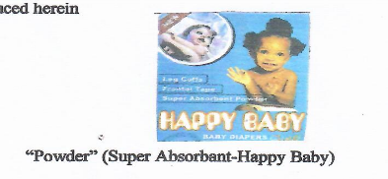
(511) | 03
(731) | FOR AND BEHALF OF: AFFILIATED TRADING COMPANY AND BARBAR MOTORS CORPORATION
(740) | ALFRED V. TUBMAN, ATTORNEY-AT-LAW, CORPORATION SERVICES (LIBERIA) INC. P.O. BOX 1597 MONROVIA, LIBERIA

(111) | LR/M/2010/00156
 | AUGUST 2, 2010
(540) | 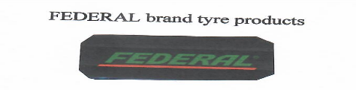
(511) | 12
(731) | FOR AND BEHALF OF: AUTO SPARE SERVICE, INC
(740) | ALFRED V. TUBMAN, ATTORNEY-AT-LAW, CORPORATION SERVICES (LIBERIA) INC. P.O. BOX 1597 MONROVIA, LIBERIA

(111) | LR/M/2010/00141
 | JUNE 7, 2010
(540) | 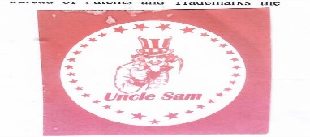
(731) | 29, 30, & 32
(740) | FOR AND BEHALF OF: SUPPLYING WEST AFRICA TRADES, INC
 | J. JOHNNY MOMOH, COUNSELLOR-AT-LAW, SHERMAN INC., R. FOLE SHERMAN LAW BUILDING, 17TH STREET AND CHEESEMAN AVENUE, MONROVIA, LIBERIA

(111) | LR/M/2010/00150
 | MAY 24, 2010
(540) | 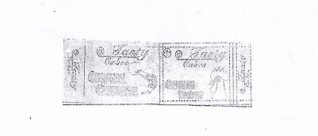
(511) | 30
(731) | FOR AND BEHALF OF: HENAN LOTUS GORUMET POWDER CO.,
(740) | G. MOSES PAEGAR, COUNSELLOR-ATLAW, SHERMAN & SHERMAN LAW FIRM, R. SHERMAN LAW BUILDING, 17TH STREET & CHEESEMAN AVENUE, SINKOR, MONROVIA, LIBERIA

(111) | LR/M/2010/00275
 | NOVEMBER 11, 2010
(540) | 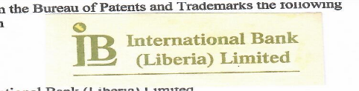
(511) | 36
(731) | FOR AND BEHALF OF: INTERNATIONAL BANK (LIBERIA)
(740) | STEPHEN B. DUMBAR, COUNSELLOR-AT-LAW, DUMBAR & DUMBAR LAW FIRM, BORAD STREET, MONROVIA, LIBERIA

(111) | LR/M/2010/00142
 | JUNE 7, 2010
(540) | 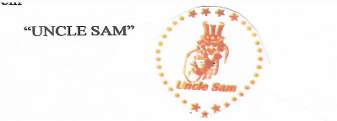
(511) | 30 & 31
(731) | FOR AND BEHALF OF: SUPPLYING WEST AFRICA TRADES, INC
(740) | J. JOHNNY MOMOH, COUNSELLOR-AT-LAW, SHERMAN INC., R. FOLE SHERMAN LAW BUILDING, 17TH STREET AND CHEESEMAN AVENUE, MONROVIA, LIBERIA

(111) | LR/M/2010/00114
 | MARCH 31, 2010
(540) | 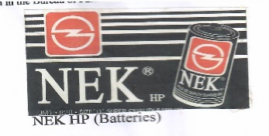
(511) | 12
(731) | FOR AND BEHALF OF: GREAT OVERSEAS INDUSTRIAL CORPORATION
(740) | DAVID A.B. JALLAH, COUNSELLOR-AT-LAW, THE DAVID A.B. JALLAH LAW FIRM, BORAD & JOHNSON STREET, P.O. BOX 4069, MONROVIA, LIBERIA

