

INDUSTRIAL PROPERTY PUBLICATION
(Expired Trademarks)

No. 08 05/20/2026

EDITORIAL
The Industrial Property Expired Trademark publication is provided for under the Liberia Intellectual Property Act of 2016, Section 10.9 and the Revised Administrative Trademark Regulation No. 001/tm/08/2018, Section 12.1 – 12.3..

Published and edited by:
Liberia Intellectual Property Office
Email: Website: lipo.gov.lr

© Liberia Intellectual Property Office 2026

PUBLICATION OF EXPIRED TRADEMARKS IN THE OFFICIAL REGISTRY SYSTEM

The Liberia Intellectual Property Office (LIPO), acting under the authority of the
Liberia Intellectual Property Act of 2016 and the Revised Administrative Trademark Regulation No. 001/tm/08/2018, hereby gives formal notice to the public, trademark proprietors, right holders, legal representatives, and all interested parties that the trademark(s) listed in this publication have been removed from the National Trademark Registry due to expiration and non-renewal in accordance with the law.

Provisions of the 2016 Liberia Intellectual Property Act

Section 10.9 – Term of Registration; Renewal:

- A trademark is registered for ten (10) years from the date of registration.
- Registration may be renewed for consecutive 10-year periods upon meeting requirements and paying the renewal fee.
- A six (6) month grace period is allowed for late renewal, subject to a surcharge.
- Failure to renew within the prescribed period and grace period will result in lapse of the registration.

Provisions of the Revised Administrative Trademark Regulation No. 001/tm/08/2018

Section 12.1 – 12.3: Outlines procedures and conditions for ten-year registration, renewals, notifications, and late renewals.

Section 13bis: A lapsed trademark (due to non-renewal) may be restored within six (6) months from removal by submitting Form M6 and paying the restoration fee.

Section 16.2: Any alteration, renewal, or removal must be recorded in the Register and published in the official LIPO Journal.

EXPLANATION OF REFERENCE NUMBERS AND SYMBOLS IN THIS PUBLICATION

(111) – Trademark Registration
(231) – Expiration Date
(540) – Trademark
(511) - Nice Classification
(731) – Owner Name
(740) – Representative/Agent Name and Address

Expired Trademark

(111) | LR/M/2008/00167
(231) | JULY 15, 2008
(540) | 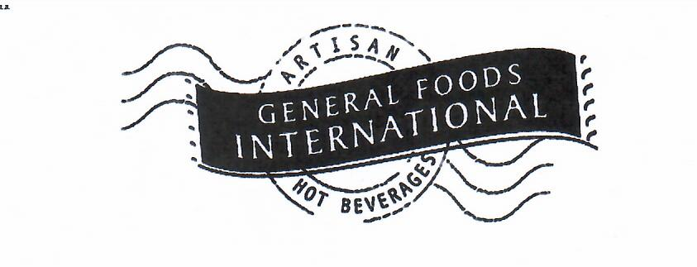
(511) | 30
(731) | FOR AND ON BEHALF OF: KRAFT FOOD HOLDINGS, INC
(740) | ALFRED V. TUBMAN, ATTORNEY-AT-LAW, P.O. BOX 1597, MONROVIA, LIBERIA.

(111) | LR/M/2008/00141
(231) | OCTOBER 15, 2009
(540) | 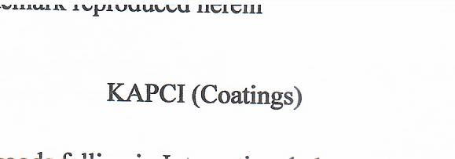
(511) | 01, 02 & 17
(731) | FOR AND ON BEHALF OF: KAPCI
(740) | ALFRED V. TUBMAN, ATTORNEY-AT-LAW, CORPORATION SERVICE (LIBERIA) P.O. BOX 1597, MONROVIA, LIBERIA.

(111) | LR/M/2008/00178
(231) | JULY 21, 2008
(540) | 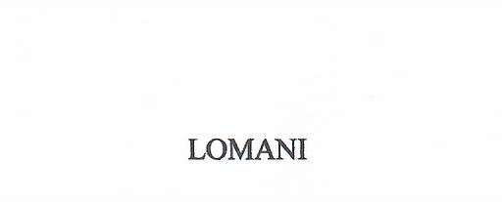
(511) | 03
(731) | FOR AND ON BEHALF OF: GOODWILL BUSINESS CENTER
(740) | ALFRED V. TUBMAN, ATTORNEY-AT-LAW, COROORATION SERVICE (LIBERIA) P.O. BOX 1597, MONROVIA, LIBERIA.

(111) | LR/M/2008/00106
(231) | APRIL 3, 2008
(540) | 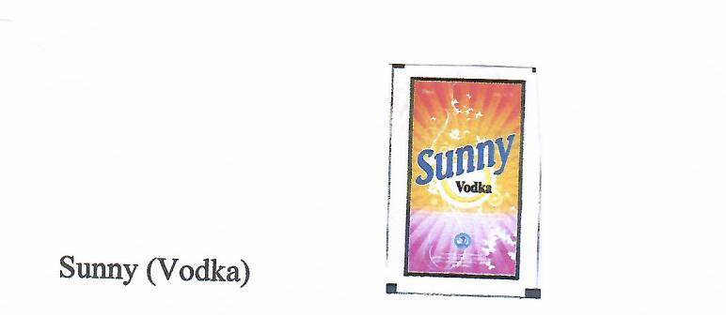
(511) | 33
(731) | FOR AND ON BEHALF OF: 1 AFRICA INDUSTRIES (LIB.) INC
(740) | DICKSON N. DOE, COUNSELLOR-AT-LAW, TWEH & ASSOCIATES, PLAM HOTEL BUILDING, BROAD & RANDALL STREET, P.O. BOX 10-2536, 1000MONROVA 10, LIBERIA

(111) | LR/M/2008/00019
(231) | JANUARY 25, 2008
(540) | 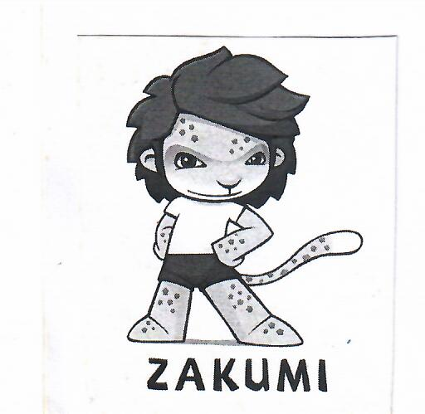
(511) | 9,14,16,21,25,28,32,36,38 & 43
(731) | FOR AND ON BEHALF OF: FEDERATION INTERNATIONALE DE FOOTBALL ASSOCIATION (FIFA)
(740) | GMAKAHN A. SHERMAN, ATTORNEY-AT-LAW, P.O. BOX 2605, 33 BENSON STREET, MONROVIA, LIBERIA

(111) | LR/M/2008/00128
(231) | JUNE 26, 2008
(540) | 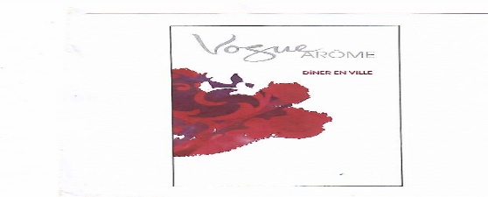
(511) | 34
(731) | FOR AND ON BEHALF OF: AMERICAN-CIGARETTE COMPANY
(740) | BENEDICT K. SAGBEH, ATTORNEY-AT-LAW, P.O. BOX 2605, 33 BENSON STREET, MONROVIA, LIBERIA

(111) | LR/M/2008/00129
(231) | JUNE 26, 2008
(540) | 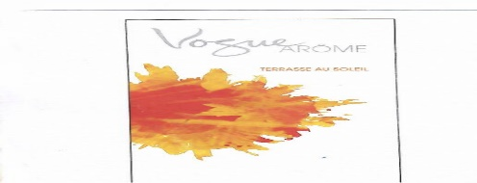
(511) | 34
(731) | FOR AND ON BEHALF OF: AMERICAN-CIGARETTE COMPANY
(740) | BENEDICT K. SAGBEH, ATTORNEY-AT-LAW, P.O. BOX 2605, 33 BENSON STREET, MONROVIA, LIBERIA

(111) | LR/M/2008/00127
(231) | JUNE 26, 2008
(540) | 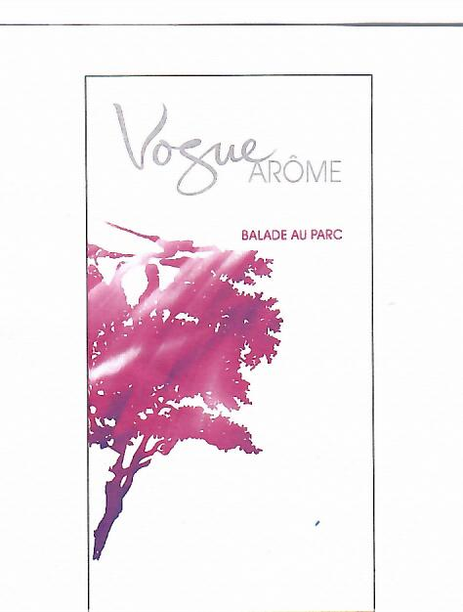
(511) | 26
(731) | FOR AND ON BEHALF OF: AMERICAN-CIGARETTE COMPANY
(740) | BENEDICT K. SAGBEH, ATTORNEY-AT-LAW, P.O. BOX 2605, 33 BENSON STREET, MONROVIA, LIBERIA

(111) | LR/M/2008/00054
(231) | FRBRUARY 25, 2008
(540) | 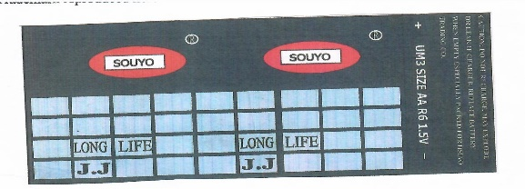
(511) | 09
(731) | FOR AND ON BEHALF OF: JUI HSIUNG HSIAO G.M. TRADING, RANDALL & WATER STREET
(740) | ALFRED V. TUBMAN, ATTORNEY-AT-LAW, COROORATION SERVICE (LIBERIA) P.O. BOX 1597, MONROVIA, LIBERIA.

(111) | LR/M/2008/00174
(231) | AUGUST 27, 2008
(540) | 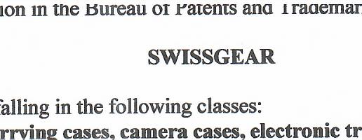
(511) | 9, 14, 16, 18, & 25
(731) | FOR AND ON BEHALF OF: WENGER NA
(740) | ALFRED V. TUBMAN, ATTORNEY-AT-LAW, COROORATION SERVICE (LIBERIA) P.O. BOX 1597, MONROVIA, LIBERIA.

(111) | LR/M/2008/00191
(231) | AUGUST 26, 2008
(540) | 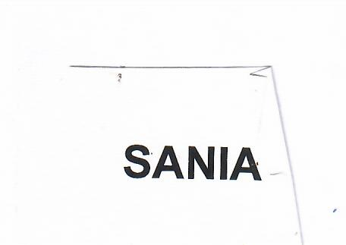
(511) | 16
(731) | FOR AND ON BEHALF OF : WILMAR TRANDING PET LTD
(740) | BENEDICT K. SAGBEH, ATTORNEY-AT-LAW, P.O. BOX 2605, 33 BENSON STREET, MONROVIA, LIBERIA

(111) | LR/M/2008/00007
(231) | JANUARY 4, 2008
(540) | 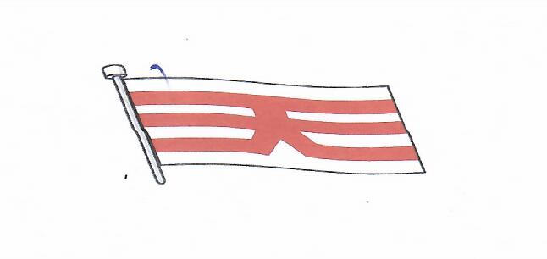
(511) | 39
(731) | FOR AND ON BEHALF OF: TSUNEISHI HOLDINGS CORPORATION
(740) | ALFRED V. TUBMAN, ATTORNEY-AT-LAW, CORPORATION SERVICES (LIBERIA) INC. P.O. BOX 1597, MONROVIA, LIBERIA

(111) | LR/M/2008/00118
(231) | APRIL 29, 2008
(540) | 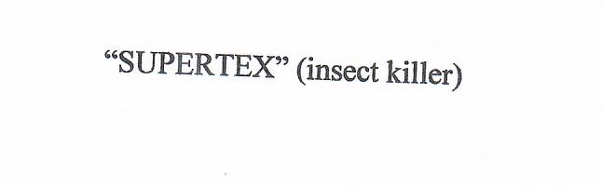
(511) | 05
(731) | FOR AND ON BEHALF OF: BARBAR MOTORS CORPORATION AND AFFILIATE TRANDING COMPANIES (ATCO)
(740) | LIOYD B. KENNEDY, COUNSELLOR-AT-LAW, KENNEDY LAW FIRM, RANDALL STREET, OPPOSITE OLD MINISTRY OF PLANNING, MONROVIA, LIBERIA

(111) | LR/M/2008/00135
(231) | AUGUST 4, 2008
(540) | 
(511) | 34
(731) | FOR AND ON BEHALF OF: BRITISH AMERICA TOBACCO (BRANDS) LIMITED
(740) | BENEDICT K. SAGBEH, ATTORNEY-AT-LAW, P.O. BOX 2605, 33 BENSON STREET, MONROVIA, LIBERIA

(111) | LR/M/2008/00140
(231) | JUNE 2, 2008
(540) | 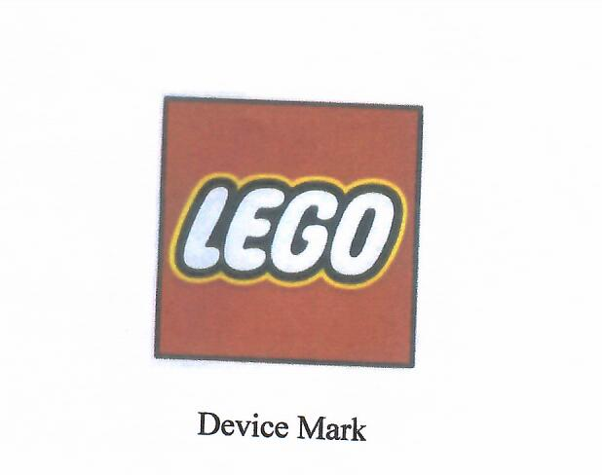
(511) | 28
(731) | FOR AND ON BEHALF OF: LEGO JURIS A/S
(740) | ALFRED V. TUBMAN ATTORNEY-AT-LAW P.O. BOX 1597, MONROVIA, LIBERIA

(111) | LR/M/2008/00256
(231) | MAY 26TH 2022
(540) | 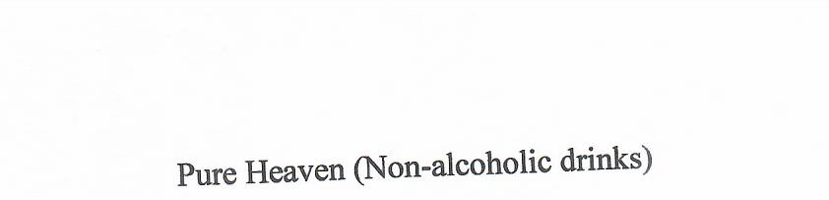
(511) | 32
(731) | FOR AND ON BEHALF OF: MONOPRIX SUPERMARKETS
(740) | ALFRED V. TUBMAN ATTORNEY-AT-LAW P.O. BOX 1597, MONROVIA, LIBERIA

(111) | LR/M/2008/00003
(231) | JANUARY 9, 2007
 | 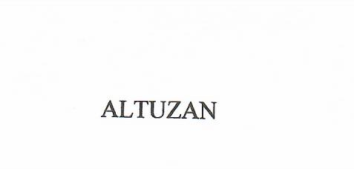
(511) | 05
(731) | FOR AND ON BEHALF OF: GENENTECH INC
(740) | ALFRED V. TUBMAN, ATTORNEY-AT-LAW, INC. P.O. BOX 1597, MONROVIA, LIBERIA

(111) | LR/M/2008/00142
(231) | JUNE 2, 2008
(540) | 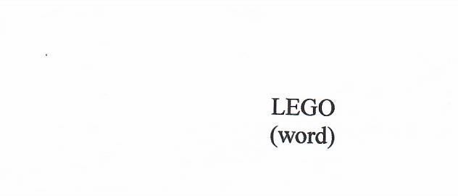
(511) | 28
(731) | FOR AND ON BEHALF OF: LEGO JURIS A/S
(740) | ALFRED V. TUBMAN, ATTORNEY-AT-LAW, INC. P.O. BOX 1597, MONROVIA, LIBERIA

(111) | LR/M/2008/00024
(231) | FEBRUARY 26, 2008
(540) | 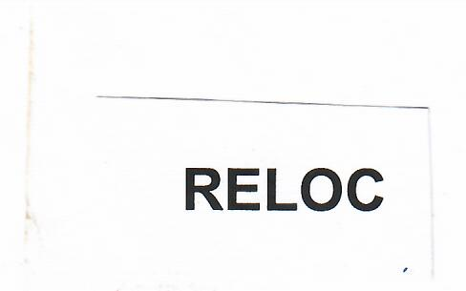
(511) | 34
(731) | FOR AND ON BEHALF OF: BRITISH AMERICAN TOBACCA (BREAND) LIMITED
(740) | GMAKAHN A. SHERMAN, ATTORNEY-AT-LAW, P.O. BOX 2605, 33 BENSON STREET, MONROVIA, LIBERIA

(111) | LR/M/2008/00023
(231) | FEBUARY 28, 2008
(540) | 
(511) | 05
(731) | FOR AND ON BEHALF OF: TIBOTEC PHARMACEUTICAL LTD
(740) | GMAKAHN A. SHERMAN, ATTORNEY-AT-LAW, P.O. BOX 2605, 33 BENSON STREET, MONROVIA, LIBERIA

(111) | LR/M/2008/00056
(231) | MARCH 5, 2008
(540) | 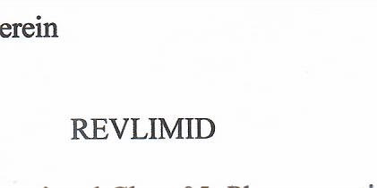
(511) | 05
(731) | FOR AND ON BEHALF OF: CELGENE CORPORATION
(740) | ALFRED V. TUBMAN, ATTORNEY-AT-LAW, . P.O. BOX 1597, MONROVIA, LIBERIA

(111) | LR/M/2008/00123
(231) | JUNE 3, 2008
(540) | 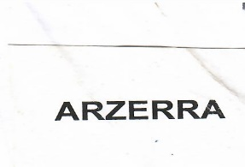
(511) | 05
(731) | FOR AND ON BEHALF OF: SMITHKLINE BEECHAM CORPORATION
(740) | BENEDICT K. SAGBEH, ATTORNEY-AT-LAW, P.O. BOX 2605, 33 BENSON STREET, MONROVIA, LIBERIA

(111) | LR/M/2008/00078
(231) | APRIL 10, 2008
(540) | 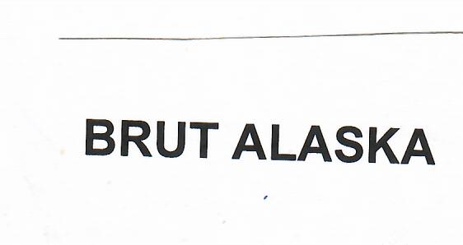
(511) | 03
(731) | FOR AND ON BEHALF OF: UNILEVER N.V
(740) | GMAKAHN A. SHERMAN, ATTORNEY-AT-LAW, P.O. BOX 2605, 33 BENSON STREET, MONROVIA, LIBERIA

(111) | LR/M/2008/00185
(231) | OCTOBER 20, 2008
(540) | 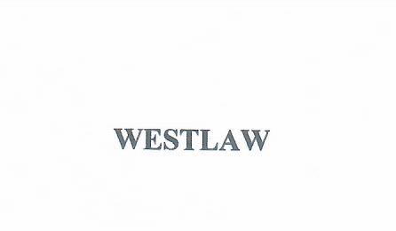
(511) | 42
(731) | FOR AND ON BEHALF OF: THOMSON FINANCE S.A. LANDIS & GYR-STRASSE 3,
(740) | ALFRED V. TUBMAN, ATTORNEY-AT-LAW, . P.O. BOX 1597, MONROVIA, LIBERIA

(111) | LR/M/2008/00057
(231) | MARCH 5, 2008
(540) | 
(511) | 03
(731) | FOR AND ON BEHALF OF: AMKA PRODUCTS (PROPRIETARY) LIMITED
(740) | ALFRED V. TUBMAN, ATTORNEY-AT-LAW, . P.O. BOX 1597, MONROVIA, LIBERIA

(111) | LR/M/2008/00117
(231) | APRIL 29, 2008
(540) | 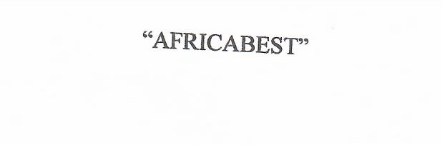
(511) | 09
(731) | FOR AND ON BEHALF OF: BARBAR MOTORS CORPORATION AND AFFILIATE TRADING COMPANIES
(740) | LIOYED B. KENNEDY, COUNSELLOR-AT-LAW, KENNEDY LAW FIRM, RANDALL STREET, OPPOSITE OLD MINISTRY OF PLANNING , MONROVIA, LIBERIA

(111) | LR/M/2008/00182
(231) | SEPTEMBER 18, 2008
(540) | 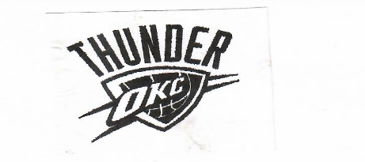
(511) | 41
(731) | FOR AND ON BEHALF OF: NBA PROPERITES, INC
(740) | ALFRED V. TUBMAN, ATTORNEY-AT-LAW, . P.O. BOX 1597, MONROVIA, LIBERIA

(111) | LR/M/2008/000122
(231) | APRIL 29, 2008
(540) | 
(511) | 35 & 37
(731) | FOR AND ON BEHALF OF: SETHI BROTHER INC
(740) | ALFRED V. TUBMAN, ATTORNEY-AT-LAW, . P.O. BOX 1597, MONROVIA, LIBERIA

(111) | LR/M/2008/00084
(231) | MARCH 24, 2008
(540) | 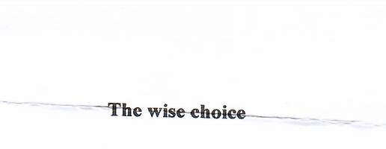
(511) | 36
(731) | FOR AND ON BEHALFN OF: UNITED BANK OF AFRICA (UBA)
(740) | SCHEAPLOR R. DUMBAR, COUNSELLOR-AT-LAW, PIERR, TWEH & ASSOCIATES, PLAM HOTEL BUILIDING , BRAOD & RANDALL STREET, P.O. BOX 10-2356, 1000 MONROVIA, 10 LIBERIA

